**Orchestrator Training Instructions**

**Please follow the steps below in order to create a new tenant in the Orchestrator training environment.**

1. Go to <https://platform.uipath.com/> and click the **Become a new tenant**button.
2. Fill in the required fields using your information: tenant name, name, surname, email address, and password.
3. Click the **Create the tenant** button and wait. This will become your own instance of the UiPath Orchestrator (**tenant**). You are automatically logged in to this tenant.
4. With one instance of Orchestrator, the multi tenancy feature enables you to define a custom number of tenants and have all the data (logs, reports, etc.) isolated for each  individual tenant (or customer). You can read more about this on <https://orchestrator.uipath.com/>.

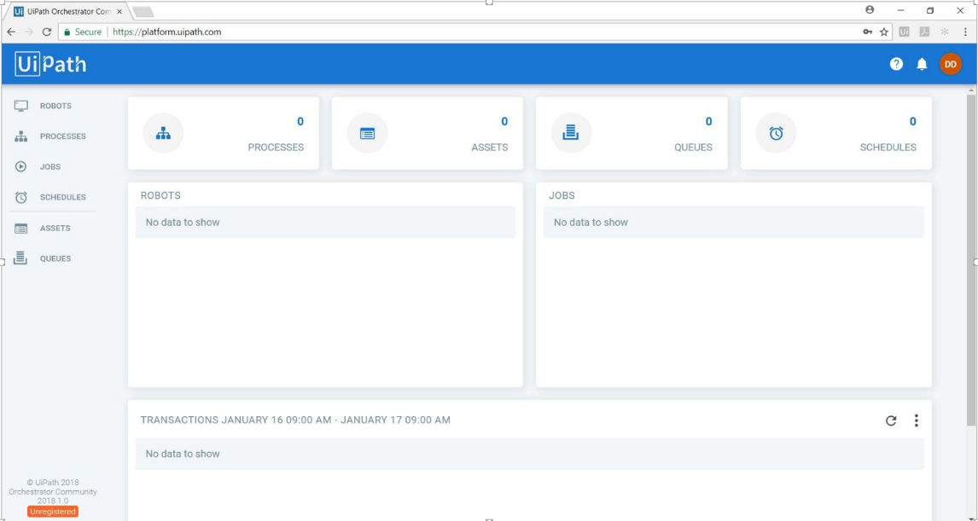

***\*Please note that tenants older than 7 days are automatically deleted.***